Задание 1.

find /etc -maxdepth 1 -group root | sed 's@^/etc/@@'

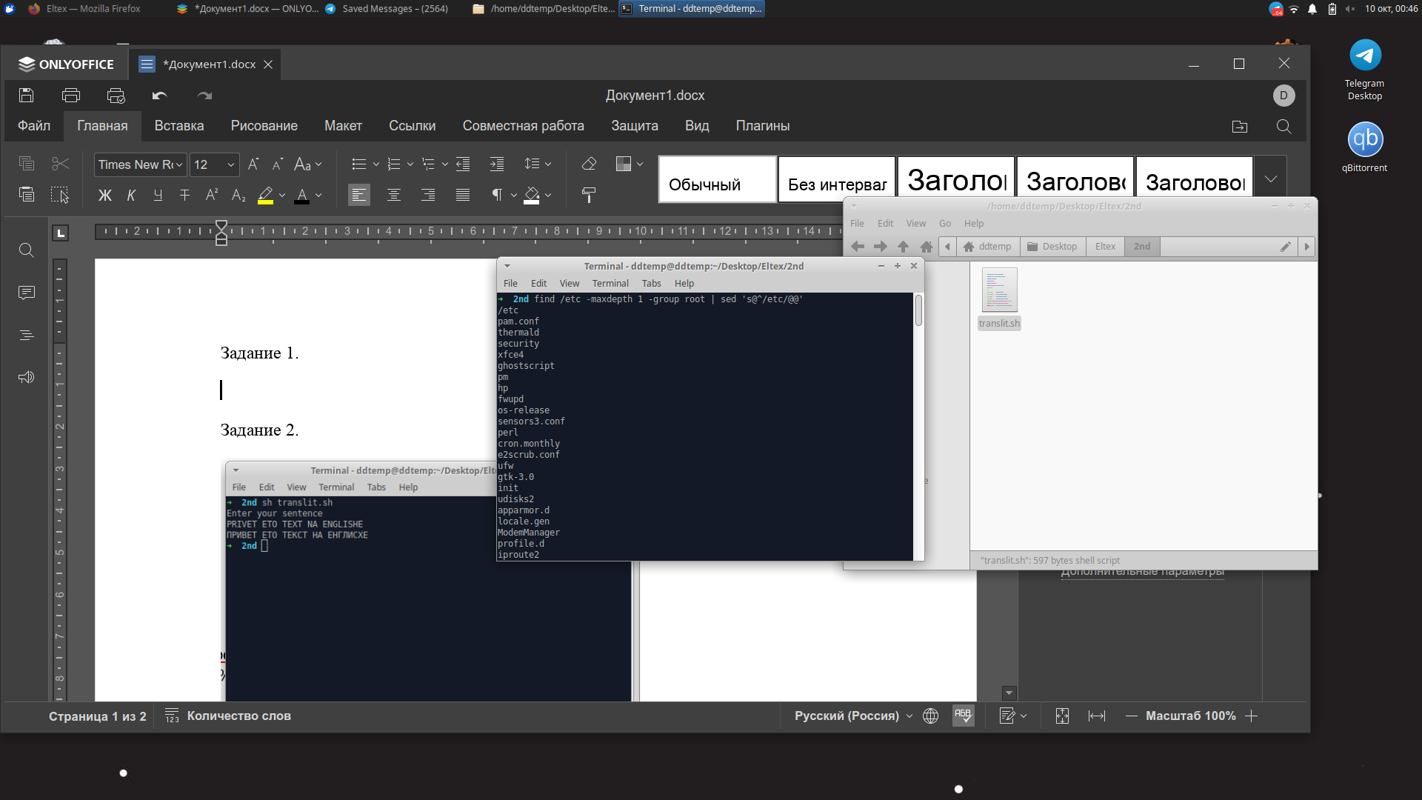

Задание 2.

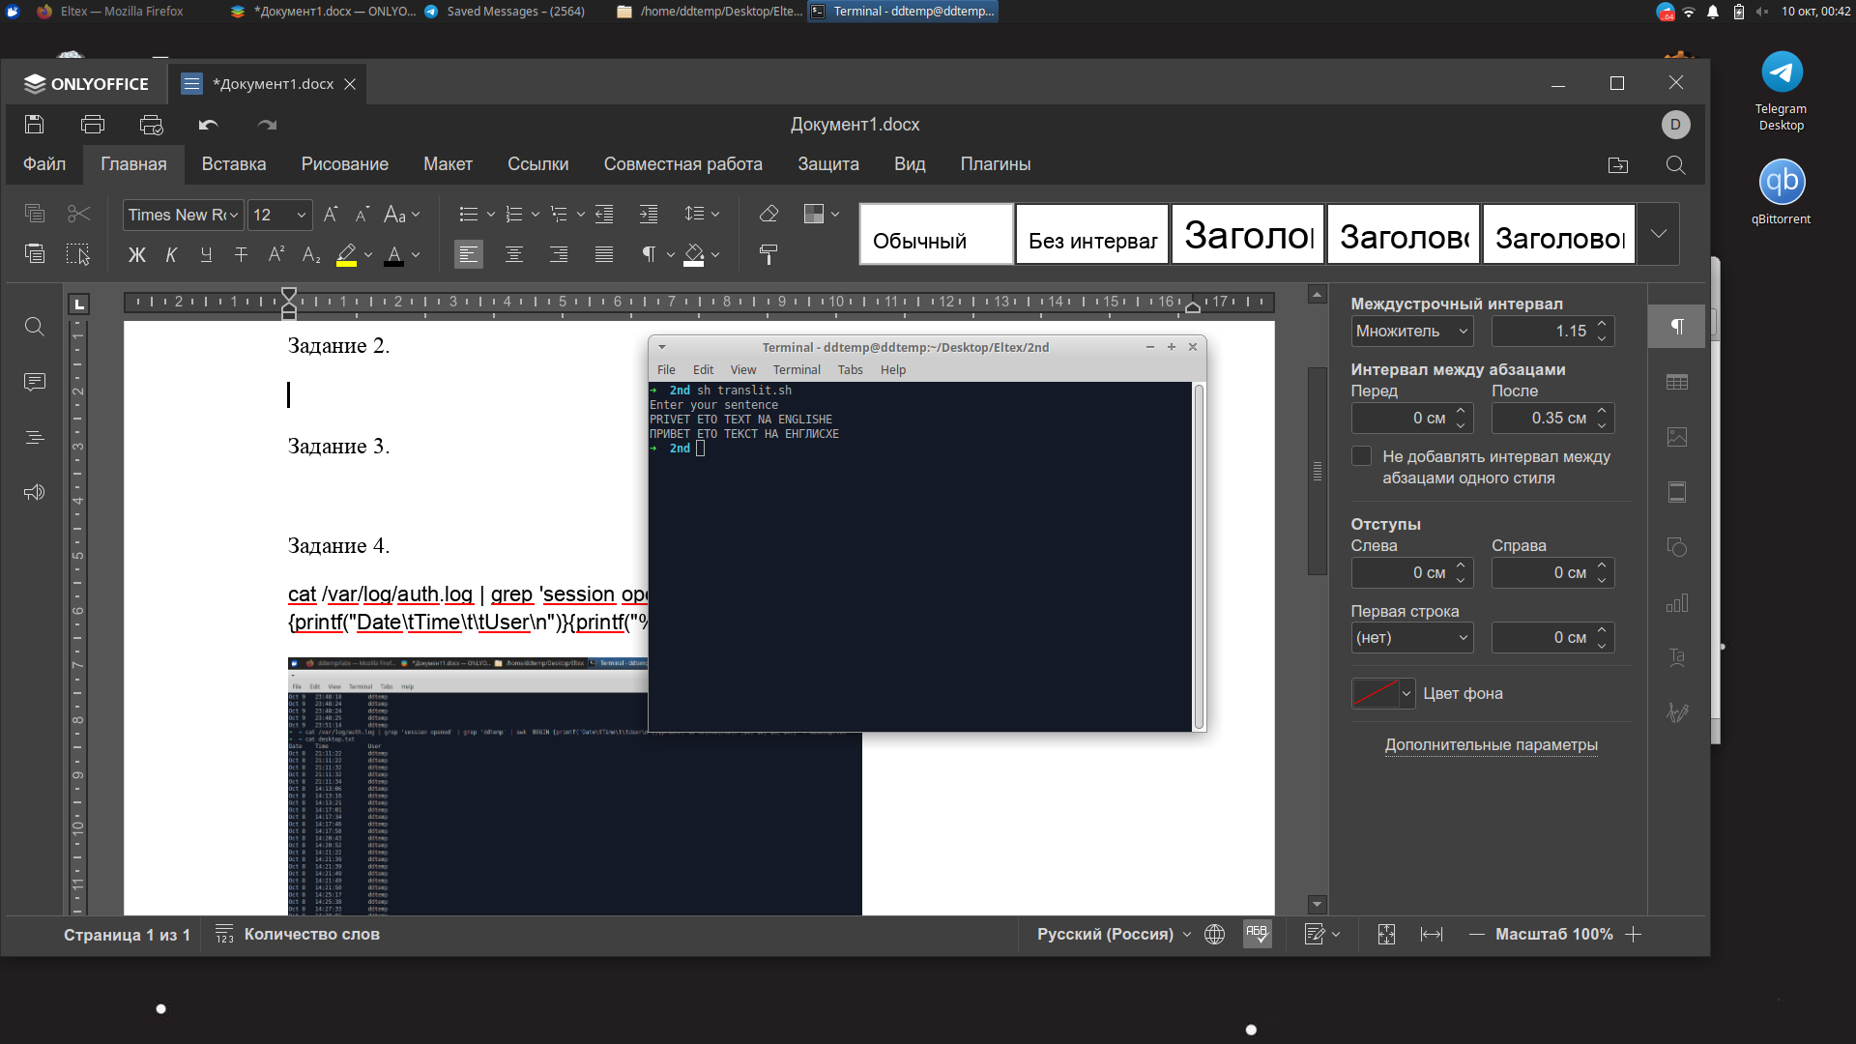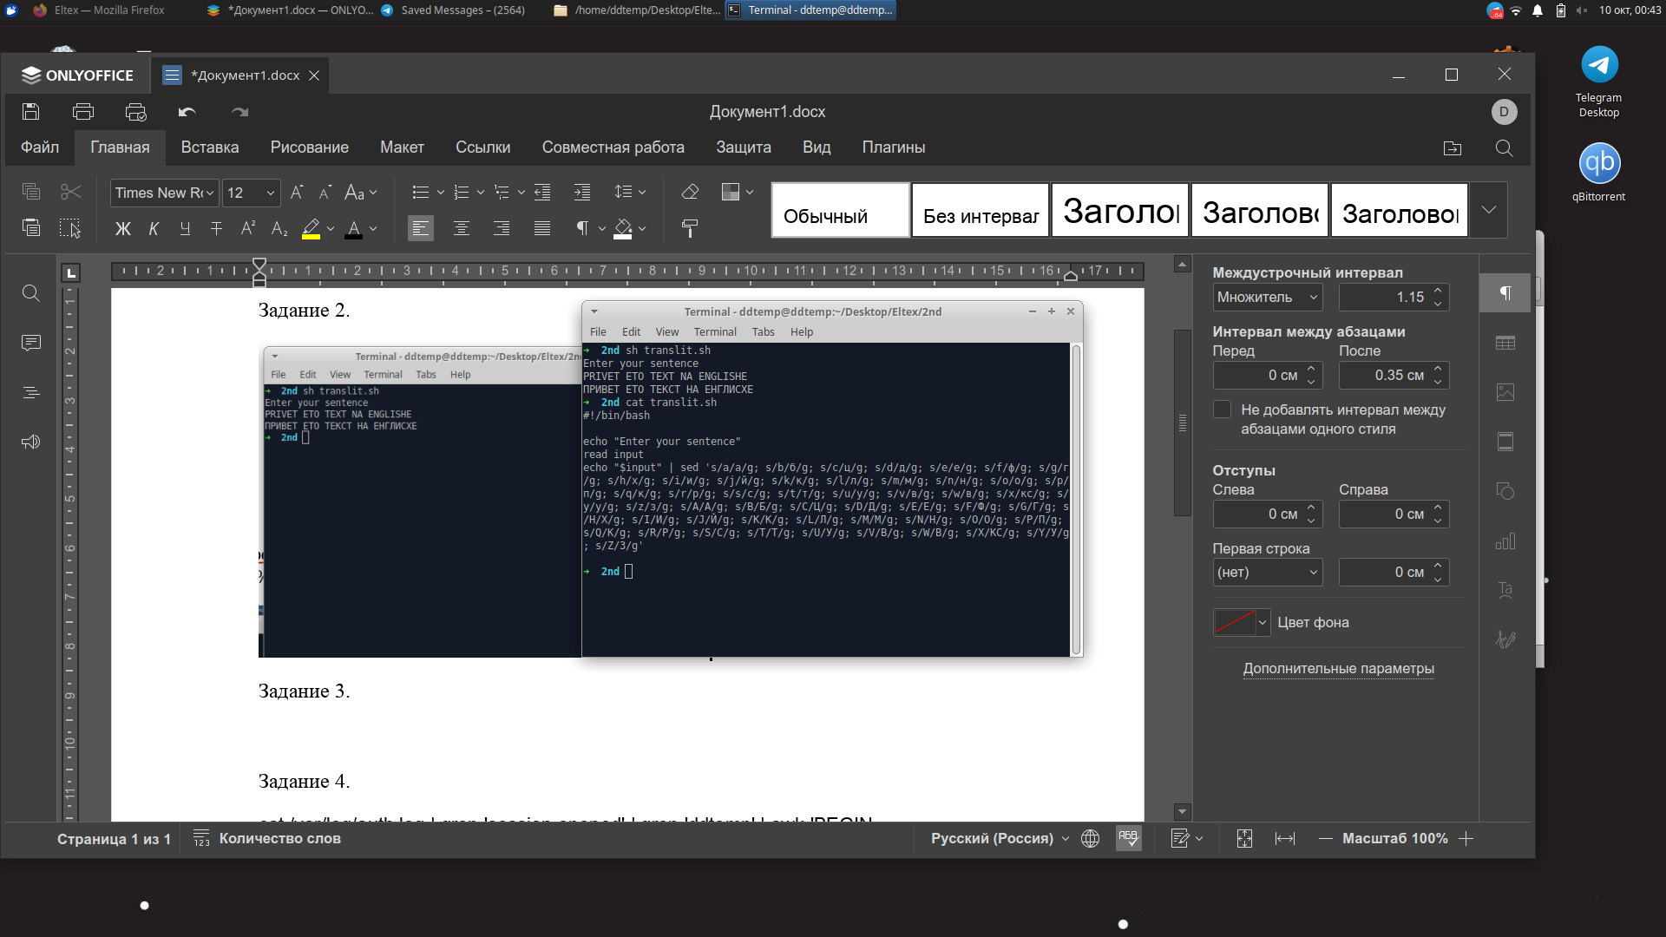

Задание 3.

sudo find / -type f -size +10M -printf "%f \t%s B\n"

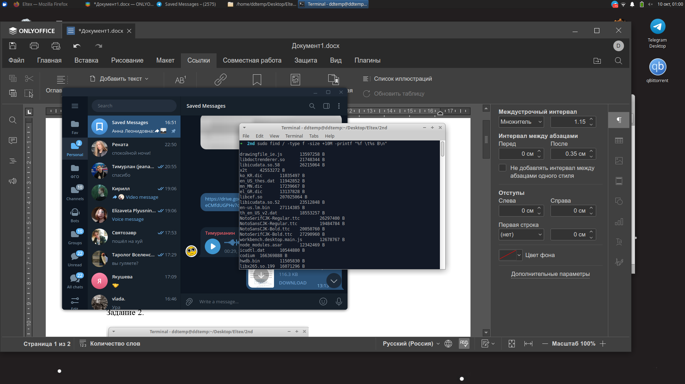

Задание 4.

cat /var/log/auth.log | grep 'session opened' | grep 'ddtemp' | awk 'BEGIN {printf("Date\tTime\t\tUser\n")}{printf("%s %s\t%s\t%s\n",$1, $2, $3, $4)}' > desktop.txt

